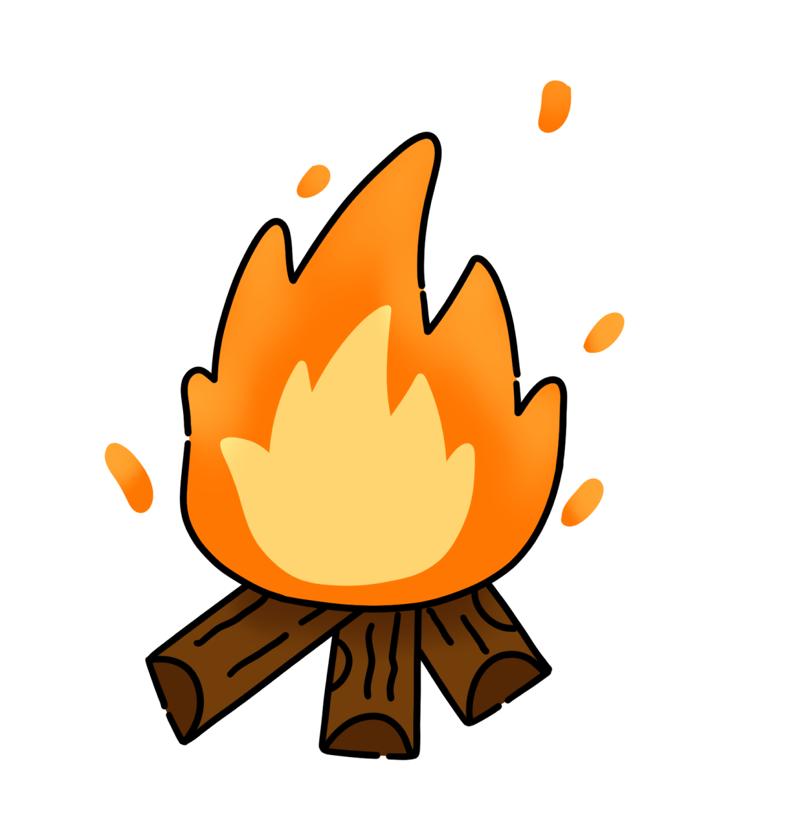

HuskyHack 2026: Minor Participant Consent & Waiver Form
Event: HuskyHack
Date: May 1st-2nd, 2026
Location: George Brown Polytechnic Waterfront Campus (51 Dockside drive), Toronto, ON
Please note that the date and time of the event is subject to changes.

1. Participant & Guardian Information
Participant Name: _____________________ Date of Birth: ___________________________
Parent/Guardian Name: ________________________________________________________
Guardian Phone: _____________________ Guardian Email: _________________________

2. Release of Liability & Assumption of Risk
I, the undersigned parent/guardian, grant permission for the Participant to attend HuskyHack. I assume all risks associated with their participation. I hereby release, waive, and discharge the HuskyHack organizing team, the Computer Science Club, George Brown College, and their respective directors, officers, employees, and agents from any and all liability, claims, or demands arising from injury, loss, or damage to person or property during the event, including overnight stays.

3. Medical Consent & Emergency Treatment
In the event of a medical emergency, I authorize the event organizers and George Brown College staff to secure necessary medical treatment for the Participant. I agree to assume all financial responsibility for such treatment.
Emergency Contact Name: _____________________ Phone: _________________________
Known Allergies/Medical Conditions: ____________________________________________

4. Media Release (Photo & Video Consent)
I grant HuskyHack and George Brown College the irrevocable right to use, reproduce, and publish photographs, video, or audio recordings of the Participant taken during the event for promotional, educational, or organizational purposes, without compensation.

5. Supervision & Conduct Agreement
I understand that while the event is supervised, organizers cannot monitor the Participant at all times. The Participant must adhere to the HuskyHack Code of Conduct and venue policies. I acknowledge that if the Participant violates these rules, they may be dismissed from the event, and I will be responsible for their immediate transportation home, regardless of the hour.
Parent/Guardian Signature: ___________________________ Date: ____________________

